**IELTS- Writing Task 1 (Pie Charts)**

**The two pie charts below show the percentages of industry sectors’ contribution to the economy in Turkey in 2000 and 2016.**

**Summarize the information by selecting and reporting the main features and make comparisons where relevant.**

**Contribution to the economy of Turkey by Sector**

**2000** **2016**

**Model Answer**

**The two pie charts** **illustrate/represent/depict/show/portray** how different industry sectors contributed to the economy of Turkey percentagewise in the years *2000 and 2016*. The industrial sectors are namely, government, Agriculture, Constructions, Manufacturing, Trade & Transportation, Healthcare & education, Finance & business and Leisure & hospitality.

**Overall/In general**, **at the beginning of the period/at the onset/in 2000** construction **contributed the least** to the economy of Turkey, **while** agriculture was the most significant economic sector. **In comparison**, **at the end of the period/towards the end/in 2016/toward the latter part** healthcare and education became the **largest** economic **segment** and the **lowest** **contribution** was made by finance, business and other services.

Construction sector **accounted for/represented/comprised/consisted of/amounted for** 3% of Turkey’s economy in 2000, and experienced a more than threefold increase in 2016. Economic income from trade, utilities and transportation was 14% in 2000 and had **a slight growth** of 2% in 2016. At the beginning of the period, manufacturing, and finance, business and other services **made up** 8% and 5% of Turkey’s economy **respectively**, and these figures rose to 12% and 8% in 2016.

Agriculture, which **comprised** almost a quarter of Turkey’s economy in 2000, **fell/drastically dropped** to 14% in 2016. In 2000, economic outputs from government and leisure and hospitality sectors were at 12% and 17%, respectively, and both **decreased** by 3% after a 16 year period**. In contrast**, contribution from healthcare and education sector **remained constant/remained stable** in both years.

**IELTS Task 1 Structure**

Introduce the chart to the readers in 1 or 2 2 sentences and 2-4 key features (varies)

**Introduction**

**Overview**

List General/ major trends of the cha chart. Overview= only general info

**Paragraph 1**

(Feature 1)

Describe specific features **(compare)**

Ex: sectors/trends that increase or g experienced an increase

**Paragraph 2**

(Feature 2)

Ex: sectors/ trends that decreased f or experienced a decrease and/or f didn’t change=remained stale

**NO conclusion** because you are asked to give your personal opinion and you have already summarized the information in the general overview.

In your paragraphs you may write specific key numbers and years to describe change

If it’s a pie chart you will have to compare which slices (sectors in written format) grew bigger in the span of time, ex from 2006- 2016 for the 1st paragraph and which sectors grew smaller within this time span.

Always highlight the largest and smallest proportions

If there are two pie charts or bar graphs in different time periods then highlight the key changes/trends

Pie chart language: accounts for/ amounts to /comprises/represents

Do not make predictions or guesses. Pick the key features and report them.

### IELTS Writing Task 1: language for describing graphs

**Useful introductory expressions:**   
The graph shows / indicates / depicts / illustrates  
From the graph it is clear  
It can be seen from the graph  
As can be seen from the graph,  
As is shown / illustrated by the graph,  
Example: The graph shows the percentage of children using supplements in a place over a year.  
  
**Useful time expressions:**

-Within the time span of/ between the time span of/ time frame of … between …& …….

-Across the years…(e.g. Sales fluctuated across the years..)

-In the beginning of the period/ At the outset/ Initially/

-Towards the end/ towards the latter part/ In the end of the period..  
-over the next... / for the following... (for the following two months... over the next six months...)  
-from ... to / between ... and (from June to August... between June and August...)  
-during (during the first three months...)  
  
**Warning!**  
**Per cent** is the word form of the symbol **%**. We can write **10%** or **10 per cent**. Percentage is the noun form: The **percentage** of children using supplements. NOT ...  
  
**Note!**You can use a combination of **adjective + noun**, or **verb + adverb**, to avoid repeating the same phrase.  
Example: There was a sharp decrease in the numbers. The numbers decreased sharply.

There was a dramatic increase in the figures. The numbers increased dramatically…

**This exercise focuses on some basic language, which you need to describe graphs. Look at the graph below. Following the graph, there are 25 statements about the data.**

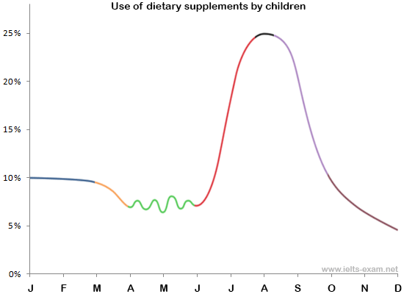

**Upward trend**

**Rise (rose, risen), grow (grew, grown), climb (-ed, -ed), shoot up (shot up, shot up), increased  
dramatic (dramatically), sharp (sharply), significant (significantly), rapid (rapidly)**

Sentence structures to be used

There was an increase in car sales in 2011 compared to buses-(noun form)

Car sales increased in 2011 compared to buses- (verb form)

There was a significant rise in car sales in 2000 - adj

Car sales rose significantly in 2000 - adverb

There was a drastic decrease in car sales in 2000- noun form

Car sales decreased drastically in 2000 – verb form

Car sales drastically decreased in 2000 – verb form

The sales rose in 2000 – verb form

There was a rise in sales in 2000- noun form

There was a dramatic rise in car sales in 2000- adj

Car sales increased dramatically in 2000- adv.  
  
-There was a significant increase in the percentage of children taking dietary supplements between June and August.  
-The period between June and August saw a dramatic growth in the use of dietary supplements.

-Between June and August, the percentage of children taking dietary supplements shot up dramatically.  
-The greatest rise was from June to August when it rose by 22% for two consecutive months from June to August.

**peaked (-ed, -ed), reach (-ed, -ed)**-The percentage of children taking dietary supplements was at its highest level in April.  
Supplement use peaked at close to 25% in April.  
-It reached a peak of 25% in April.

**remain (-ed, -ed)  
unchanged, steady, stable, constant, plateau, fixed/static**  
-From January to March the percentage of children using supplements remained fairly static at approximately 10%.  
-The percentage of children taking dietary supplements was relatively stable during the first two months of the year.  
-During the first two months, supplement use remained fairly unchanged.

**Decreasing Trends: fall (fell, fallen), decreased (-ed, -ed), drop (dropped, dropped), plunged (-ed, -ed), declined (-ed, -ed)/ Plummeted (-ed)**  
slight (slightly), steady (steadily), gradual (gradually), gentle (gently), slow (slowly)  
downward trend  
  
-It then fell gradually in March.  
-There was a slight decrease in the use of dietary supplements in March.  
-The graph shows a slight decrease in March.  
-Supplement use experienced a steady decrease in March.  
-Supplement use decreased slightly in March.

**fall (fell, fallen), decrease (-ed, -ed), drop (-ed, -ed)  
dramatic (dramatically), sharp (sharply), significant (significantly), rapid (rapidly)**  
  
-Between August and October, this figure dropped dramatically to 11%.  
-From August to October, there was a drop of 14% in the percentage of children taking dietary supplements.  
-Between August and October, There was a considerable fall in the percentage of children using supplements.  
-This was followed by a sharp drop of 14% over the next two months.  
-Supplement use experienced a dramatic fall between August and October.

-Between October and December, the decrease in the use of dietary supplements was at a much slower pace than in the previous two months.  
-Supplement use continued to fall steadily over the next two months until it reached its lowest point in December.  
-It fell to a low of only 5% in December.

**Fluctuate** (-ed, -ed)  
wildly/ constantly  
  
-It went up and down widely over the next two months.  
-It fluctuated for the following two months.

**IELTS Writing Task 1- Bar Charts**

**The bar chart shows the divorce rates in two European countries from 2011 to 2015.**

**Summarizing the information by selecting and reporting the main features and make comparisons when necessary.**

*Answer* Fluctuated

*The bar chart* **provides information** about the percentages of divorces in Finland and Sweden **between** 2011 and 2015.

**Overall**, Sweden **experienced a downward trend**, **while** Finland **showed an upward trend** throughout the period. Both country’s divorce rates had some **fluctuations**. Although Finland initially had a lower rate, it outraced Sweden at the end of the period.

Sweden’s divorce rate was about 45% in 2011, being higher than Finland’s rate by **approximately** 8%. Then, it **rose** to almost fifty percent in 2012. **However,** the figure showed **a gradual decrease** to about 47% in 2013, and **continued to decline steadily** to the end of the period, reaching around 45% in 2014 and hitting a low-point of about 37% in 2015.

Percentage of divorces in Finland was less than 40% in 2011, and it **decreased** in 2012, when about **one third** of marriages in Finland ended with divorce (as opposed to almost a half in Sweden). However, the figure experienced **a steady growth** during the next two years. It rose to approximately 39% in 2013, then **increased** by around 3% in 2014, and **remained steady** for the next year, outracing the rate of Sweden.

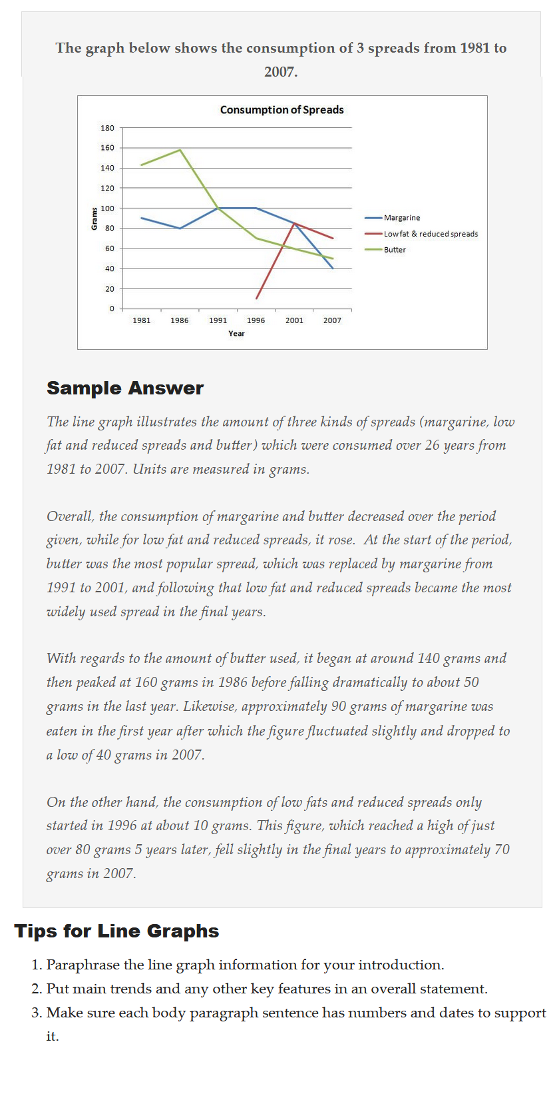

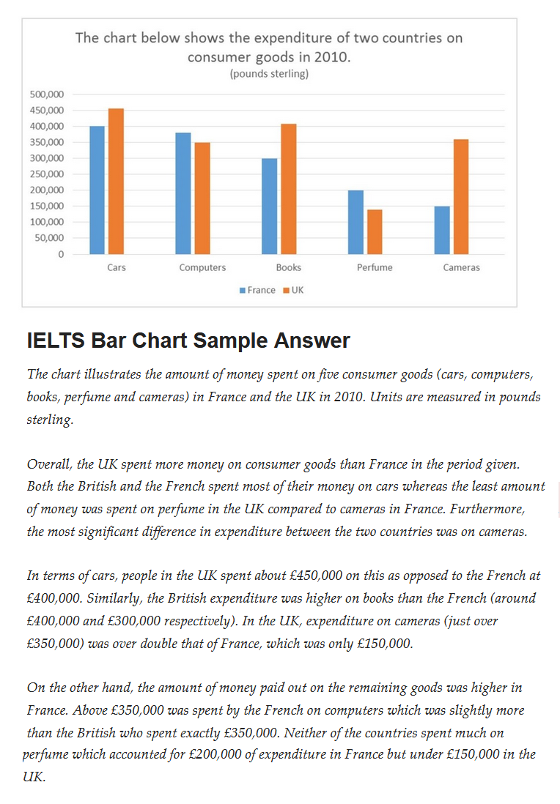

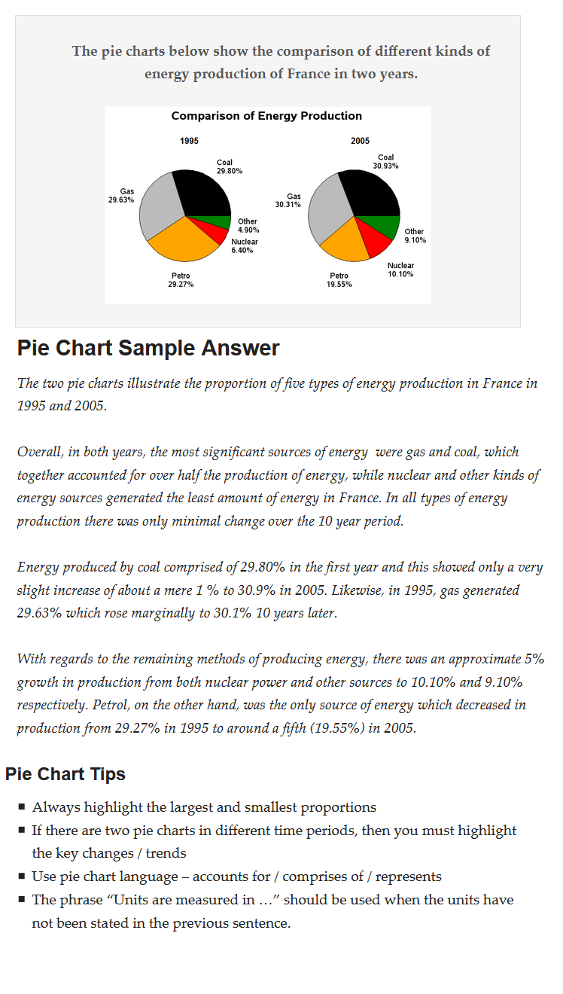

**Now complete the introduction!**

**IELTS Writing Task 2- The Essay**

**Structure**

Introduction

Paraphrase the topic and present your 11 opinion

Body Paragraph 1

Write the first reason (supporting point o of your opinion

Body Paragraph 2

Write the second supporting point

Conclusion

Briefly summarize what you have aleady already written.

**Organization of points in the body paragraphs**

**Paragraph**

**Sentence 1**- State the reason why you agree/disagree

**Sentences 2-3** – Explain your reasons for the above

**Sentence 4** - give an example

**Sentence 5** - Write a short summary of your ideas

**IELTS Writing Task 2 – The Academic Essay (250 words)**

**Fill in the formula**

**Introduction:** Element 1 …………………………………………………………………………………………

Element 2 …………………………………………………………………………………………

Element 3 …………………………………………………………………………………………

**Body paragraphs**: Element 1 ……………………………………………………………………………………

**2 to 3** Element 2 …………………………………………………………………………………….

…………………………………………………………………………………….

……………………………………………………………………………………

Element 3 ………………………………………………………………………………….

**Conclusion:** Element 1 …………………………………………………………………..

Element 2 …………………………………………………………………..

**Model Answer**

**A bigger salary is much more important than job satisfaction.**

Do you agree or disagree?. Provide examples if necessary. Write at least 250 words.

1st Opinion: Big salary is more important

* Having a job with a high salary makes people feel satisfied regardless of the job they do
* Money is essential for survival and good living

2nd Opinion: Jo satisfaction is more important

* + Job satisfaction gives you a sense of fulfillment and makes you more productive
  + Doing what you like keeps you motivated and therefore leads to career growth and success
  + Money can’t buy happiness and it’s more pleasant to pursue what you’re interested in.

-Your neutral background sentence should be a general unbiased approach based on the topic which you intend to address.. You can either start with the subject itself or be creative and thoughtful.

-To start **paraphrasing**, you can use the following expressions

**-Introduction:** (Introductory expressions) It is argued that……………..

It is considered that…………………./

It is thought that……………………/

* **Paragraph A:** Firstly,
* **Paragraph B:** Secondly, ………………… therefore…
* **You need to focus on using linking devices in your essay…**
* **Providing examples:** For example/ for instance/ a case in point is,……………………
* **Conclusion**: To conclude

In conclusion

To sum up

To summarize + Restate your opinion + restate two reasons

**Model Answer (Please note that this is just one approach out of several other possible approaches)**

The career of an individual plays a key role in determining the quality of life as well as personal gratification. **It is often argued that**/ **It is believed that/ It often identified that** it is more advantageous to choose a job with high remuneration even if it doesn’t appeal to a person at all. **I completely disagree with this opinion** since ***job satisfaction is much more important than money in life, which will be the discussion of this essay.***

**Firstly,** it is believed that every individualhas a vocation for the right career which will motivate and inspire him to become a successful professional in the chosen field. When individuals truly find their groove they will become more innovative and creative in what they do which will help him to build a confident personality and gain rewards than those who prioritized money in their life. **A case in point** is Henry Miller who decided to love his everyday job despite a good wage and ventured to become a writer. After a very tumultuous time in his life he became one of the most famous and well-paid authors of the twentieth century.

**Secondly**, career satisfaction gives people a sense of fulfillment and gratification that money can never guarantee. Despite a higher income, if the individual still feels tensed and unhappy with the work he does and also has to compromise with his conscience will make him perform his duties and responsibilities in a perfunctory manner. This scenario will have a direct impact on his productivity as well. **For example,** most successful people in the world reached such a peak in their professions because they were passionately engaged in their work. **Therefore**, the choice of a career should ensure personal happiness.

**In conclusion**, It is evident that job satisfaction is more beneficial than high salary because it keeps people happy and motivated which helps them become successful in their professional life that will ultimately contribute to personal success.

Words: 280

***Note: Without writing I agree/ In my perspective you can also state your opinion as follows***

The career of an individual plays a key role in determining the quality of life as well as personal gratification. **It is often argued that**/ **It is believed that/ It often identified that** it is more advantageous to choose a job with high remuneration even if it doesn’t appeal to a person at all. **~~I completely disagree with this opinion~~** ~~since~~ ***~~job satisfaction is much more important than money in life, which will be the discussion of this essay.~~ This essay will discuss the prime importance of job satisfaction in life, more than money***